

Military Institute of Science & Technology

Department of Computer Science & Technology

CSE – 360 (IDP)

**SYSTEM REQUIREMENTS SPECIFICATION(SRS)**

**Version 2.0**

For

Digital Logbook Maintenance System



**Date: September 30,2020**

**Prepared By**



**Members:**

|  |  |  |  |  |
| --- | --- | --- | --- | --- |
| Ser | Student ID | Name | Email | Sign |
| 1. | 201614107 | Ishrak Jahan Ema | ishrakema01@gmail.com |  |
| 2. | 201714101 | Md Safkat Rahman | safkatrahman31@gmail.com | D:\Dig Sign.jpeg |
| 3. | 201714103 | Tanvir Nahian Swapnil | zabulanakakil@gmail.com |  |
| 4. | 201714109 | Labiba Islam | labiba.islam24697@gmail.com |  |
| 5. | 201714113 | Lopa Ahmed | Lopaahmed296@gmail.com | C:\Users\USER\Downloads\WhatsApp Image 2020-09-30 at 7.13.21 PM (1).jpeg |

**Project Advisors:**

* **L**t **C**dr **A**nisur **R**ahman
* **L**ec **S**umaiya **A**froz **M**ila

***Page i***

**Table Of Contents …………………………………………………………….. Page ii**

**Preface……………………………………………………………………………..… Page iii**

1. **Introduction………………………………………………………………………………. 1** 
   1. Purpose………………………………………………………………………. 1
   2. Intended Audience ………………………………………..…………… 1
   3. Product Scope……………………..……………………………………… 1
2. **Glossary………………………………………………………………….………………… 2**
3. **Overall Description………………………………………………………….……….. 4**
4. **Requirement Discovery………………………………………………….…………. 5**
5. **User Requirements……………………………………………………………….….. 5**
6. **System Architecture………………………………………………….…………..…. 5**
7. **System Requirements Specification…………………………….……….…… 6** 
   1. System Requirements……………………………………………….… 6
      1. Image Processing……………………………………………………..… 6
      2. Authentication approval…………………………..…..……………. 6
      3. Authentication checking……………………....………………….… 6
      4. Barcode Generation and Scan……..………..……………….…… 6
      5. Job card updating…………………..……………..………..……….…. 6
      6. Feedback…………………………..…………………..……………………. 7
      7. Overall supervision……..…………………………………………….… 7
      8. Updating database from Job Card…………………………..…... 7
   2. Requirement Classification…………………………………….……. 7
8. **System Model……………………………………………………………….…………… 8**
   1. Context Diagram……………………………………………………….…. 8
   2. Use Case Diagram…………………………………………………….….. 8
   3. Activity Diagram……………………………………….……..….………. 9
   4. Sequence Diagram……………………………………..………….….… 11
9. **System Evolution………………………………………………………………….….… 12**
10. **Appendices………………………………………………………………………….……. 13**

***Page ii***

**Preface**

Bangladesh Army is one of the most traditional military organizations of the world. We follow the rules and regulations that are being in practice over a long period of time. Like the vehicle logbook maintenance system. From the beginning they are being maintained in a logbook which is a hardcopy. Hardcopies have a wide range of disadvantages. Some of the which are the preservation of them over a long period time, security issues, quick response in workshop. Moreover, the main task of an army in peace time is to prepare for war. Considering the crisis moments, the logbook is an important piece of document but very vulnerable. In the wrong hands, passing down information about it to the enemy will result in a great harm for us. As by vehicles we include tanks, APCs, artillery guns, pickups, jeeps, 3 tons and everything else, which play significant roles in war.

Now with the advancement of technology we are going to improve the system as many of the military organizations of the developed countries are following. We will not only remove this hardcopy from the system but also to get the full advantage and well responsive system we will be building an entirely new technology-based system for us. This will result in requirement of less man power, more time efficient and will have a clear record of all the vehicles along with full security, authentication of any work permits as well as will have the updated response on the progress on any work in the workshops.

As a result of our new system we can have a full secure system, the responsible officers can easily monitor all the progressive works of all the vehicles which will save time and can also plan easily on the vehicles that need to be repaired or maintained with high priority.

Hence our system will greatly facilitate our army and we will have technological advancements in this field which we still don’t have.

***Page iii***

**1. Introduction**

**1.1. Purpose**

The current system prevailing for logbook maintenance is ages old with many loop holes. It works slow, more man power is required and the system lacks proper authenticity and security along with information confidentiality. DLMS will improve our existing system in all possible ways. The purpose of this project is to digitalize the vehicle logbook maintenance process. It is aimed to provide digital platform to the logbook including whole repair procedure and to reduce workload and ambiguity.

**1.2. Intended Audience**

The project is a prototype for DLMS and should be strictly confined within military personals only. DLMS will be build and developed under the guidance of our instructors in MIST. The intended audience for this project is the persons and units or directorates related vehicle and equipment issue and management. Those are:

**1.2.1.** User Unit: the unit sending vehicles for repair mainly QM and MTO.

**1.2.2.** Workshops: Mostly Field Workshop Company as well as medium and base workshops and their repair side.

**1.2.3.** Army Headquarters (ST Dte, Ord Dte): For overall surveillance of maintenance and control the procedure.

**1.2.4.** EME Dte (Workshop Branch)

**1.3. Product Scope**

DLMS will be used in the workshops for the maintenance of the vehicles, all the necessary data of every individual vehicle, of every unit in the garrison will be in account, about the previous history of repair, changing of parts or routine check-ups with every minute details or observations will be kept into account. Even the next dates of changes of parts or cleaning or maintenance dates will also be shown. Moreover, if there is any change of parts, a specific code on all the parts will be kept in account which part is going for which vehicle in particular. But most importantly everything will undergo a secured process with the authorized personnel appointed for this task. Then again there will be verification of the vehicle that comes to the workshop with or without proper authority. The present system does everything in hardcopies, it will be digitalized and given with limited access through responsible personnel only starting from the entry of vehicle in the workshop. Hence, we will be able to mitigate all the drawbacks of the prevailing system.

1

**2. Glossary:**

* 1. **FWC:**

Field Workshop Company is a unit present in every division of Bangladesh Army which gives support in aspects of inspection, repair, recovery of the vehicles, arms and ammunition and supply spare parts as required.

* 1. **QM**:

Quarter Master is a vital appointment in a unit ensures receive, maintenance, storage and demand of ration, forage, clothing, equipment, arms and ammunition etc. of a unit. He also performs the duty of MTO if no MTO is authorized.

* 1. **MTO:**

Mechanical transport officer is the officer responsible for Mechanical transports of a unit in fact all type of vehicles.

* 1. **Workshop officer:**

Workshop officer is the appointment of a field workshop company who supervises all kind of repair and other activity of the workshop.

* 1. **Logbook:**

Logbook is a book containing each and every history of a vehicle or other equipment including arms and Artillery guns or tanks. It contains issue date from CMTD, any kind of repair history, spare parts issued, parts changed, tyre changed, oil & filter change, KMPL and also data of annual inspection and must be signed and closed by workshop officer.

* 1. **RI & I:**

It is the vital section of a workshop where a vehicle or equipment is received while entering into the workshop for repair. It means Receive, Issue and Inspection.6 persons are authorized in RI & I who performs all kind of entries in logbook.

* 1. **Work Order (WO)** :

Work order is the form opened by unit signed by QM before sending any equipment to workshop for repair.

2

* 1. **Job Card:**

When work order is deposited to RI & I, a job card is opened against it. It contains the details of parts required, repairs done to that vehicle or equipment and duly signed by workshop officer.

* 1. **Workshop NCO**:

Workshop NCO is responsible for conducting repair procedure of the vehicle or equipment coming to workshop by sending it to respective section and supervising the procedure.

* 1. **BA NO**:

BA no is the unique identification no given to every vehicle, small arms, equipment, tanks and artillery guns of Bangladesh Army. A number plate is attached to every vehicle showing respective BA no.

* 1. **2FA:**

Two factor authentications are a way to verify a user’s identity before granting login access. When logging in, two factor authentication requires the user to prove their identity in two different ways. There are many methods of authentication like via push notification, SMS passcode, phone calls, tokens and more.

* 1. **DCE:**

Data communication equipment are the hardware interface and ard for modems, protocol converters and other communicational equipment. To interface DCE devices with DTE (Data terminal Equipment) devices such as terminals or PCs, a straight through serial cable is required.

* 1. **Decoder:**

As part of a bar code reading system, the electronics that process the signals from the scanner, interpret the signals into meaningful data, and control the interface to other devices.

* 1. **Asynchronous Communication**:

Also referred to as start/stop transmission. Every character transmitted has special bits attached, telling the receiving device when the data begins and ends. Data is transmitted independently with no associated clock. See also Synchronous communication.

3

* 1. **Scanner:**

A scanner is an input device that scans documents such as photographs and pages of text. When a document is scanned, it is converted into a digital format. This creates an electronic version of the document that can be viewed and edited on a computer.

* 1. **SUI:**

The Server User Interface is the interface to the file storage system (whether it is the normal file system, a database, or other versioning repository) that stores the information that is passed through the user interface.

* 1. **Bitmap:**

A bitmap is a digital image composed of a matrix of dots. When viewed at 100%, each dot corresponds to an individual pixel on a display. In a standard bitmap image, each dot can be assigned a different colour.

**3. Overall Description**

**3.1. Project Objective:** To build a device which can identify any mil vehicle, a scanner to scan the barcode in any spare parts of vehicle and a software that contains a database linked with the devices.

**3.2.**  **User class:**

**3.2.1.** QM will use the project to give authentication for the vehicle under his supervision for going in workshop, see the work progress and condition of the vehicles under him.

**3.2.2.** Workshop Officer will use the project to supervise and monitor the overall process in the workshop.

**3.2.3**. Workshop NCO will identify the vehicle and scan the parts that will be used in the vehicle including the maintenance work.

**3.2.4.** RI & I will update the logbook according to the report of the workshop NCO and the process will be verified by the Workshop Officer.

4

**3.3. Operating Environment:**

Our project will mostly be used in the workshop then in the office of QM, Workshop Officer, Workshop NCO and RI&I. other than the office of these people it is very less likely to be used elsewhere.

**4. Requirement Discovery**

**4.1**The idea of transforming a manual data to digital data was found and this will be done through database management. (Annex A, Annex B)

**4.2.** To gain on ground knowledge of how the process actually works we went to visit the nearby workshop and saw how a logbook is maintained and how the vehicle is maintained and what are the things done during a maintenance project (Annex C) .

**4.3.** We talked with the RI&I and workshop officer and asked for their difficulties and suggestions therefore we got our main requirements from them (Annex D).

**4.4.** We then talked with the QM of 11 Signal Battalion and asked him how on the QM’s part a vehicle is maintained that actually is on ground maintenance.

**5. User Requirements**

Through requirements Discovery process we have found the following requirements:

**5.1.** security has to be ensured and given with highest priority.

**5.2.** The product should have App version usable on mobile mainly for android.

**5.3.** The App should have access for Read-only purpose.

**5.4.** Digitalized version of logbook updating and maintenance should be provided.

**5.5.** Digitalized version for work order and job card to be provided.

**5.6.** Authentication system must be provided from both user unit and workshop.

**5.7.** Repair process mainly spare parts supply should be digitalized.

**5.8.** Overall monitoring system should be provided from workshop end.

**6. System Architecture:**

5

**7. System Requirements Specification**

**7.1. System Requirements:**

**7.1.1. Desktop version:**

Desktop version and a database to be created for storing logbook information. Updating of this database should be only accessible to RI & I. Own secured server to be used in the workshop end.

**7.1.2. Image Processing App version**

The image of the vehicles identifying number that is BA Number will be taken and processed to get access to that vehicle’s individual logbook. Mobile app version will be used for it.

**7.1.3. Authentication approval**

QM of the unit, the vehicle is from, will be given access to all the vehicles he owns log book and will be only able to read information and allow it to go for repair. This authority will be required to be taken from the workshop officer for the concerned QM via any mailing system.

**7.1.4. Authentication checking**

When a new vehicle approach for repair the authority of that repair should be checked from the QM’s permission in order to avoid unwanted incidents. Without proper authority no vehicle should be repaired.

**7.1.5. Digitalization of repair process.**

As the vehicle is being repaired new parts will be transplanted and older ones will be removed. A barcode generation system will be used on the part to label them and a scanner will be used on only those parts that are going to be used for this repair purpose.

**7.1.6. Job card updating**

Since all initial data of the repairs will be placed in the job card first therefore the updating of the job card should be able to be done form main server. Several job cards can be kept open at the same time and can be updated at the same time.

6

**7.1.7. Updating database from Job Card**

Job cards information will be collected automatically from server and the log book will be auto filled up from the given updated fields of the job card

**7.1.8. Overall supervision**

The workshop officer will get the authority to make any ongoing job pending or speed up the process or even can cancel process. Again, he can check back any job already done and passed to him for confirmation. He will give authority for a vehicle to return back to unit via final confirmation and closing of logbook.

**7.2. Requirement Classification**

|  |  |  |  |
| --- | --- | --- | --- |
| **Serial** | **User Requirements** | **Types of**  **Requirements**  **(functional)** | **Types of**  **Requirements (Non-**  **Functional)** |
| **1** | **The App should be highly secured** | **X** | **√** |
| **2** | **The App should be portable in mobile devices** | **√** | **√** |
| **3** | **The App should be able to be read-only purposes** | **√** | **X** |
| **4** | **Digitalization of logbook updating and maintenance** | **√** | **X** |
| **5** | **Authentication system** | **√** | **X** |
| **6** | **Digitalization of spare parts supply process** | **√** | **X** |
| **7** | **Digitalization of work orders and job card** | **√** | **X** |
| **8** | **Overall monitoring system** | **√** | **X** |

7

**8. System Model:**

**8.1. Context Diagram:**

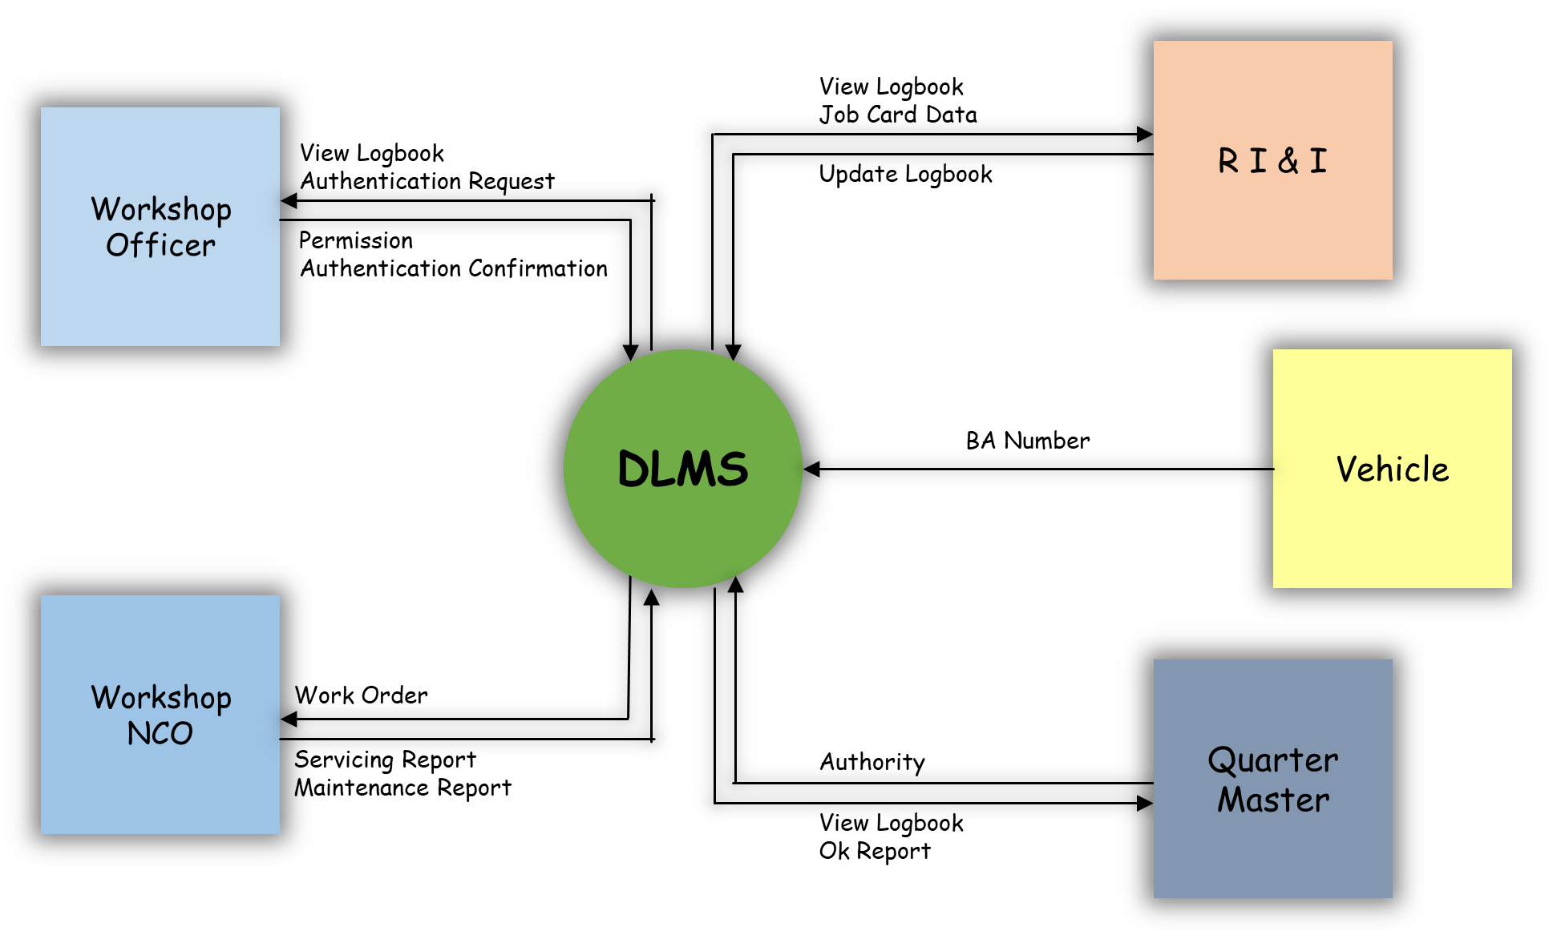

**8.2. Use Case Diagram:**

**Scenario From Unit end:**

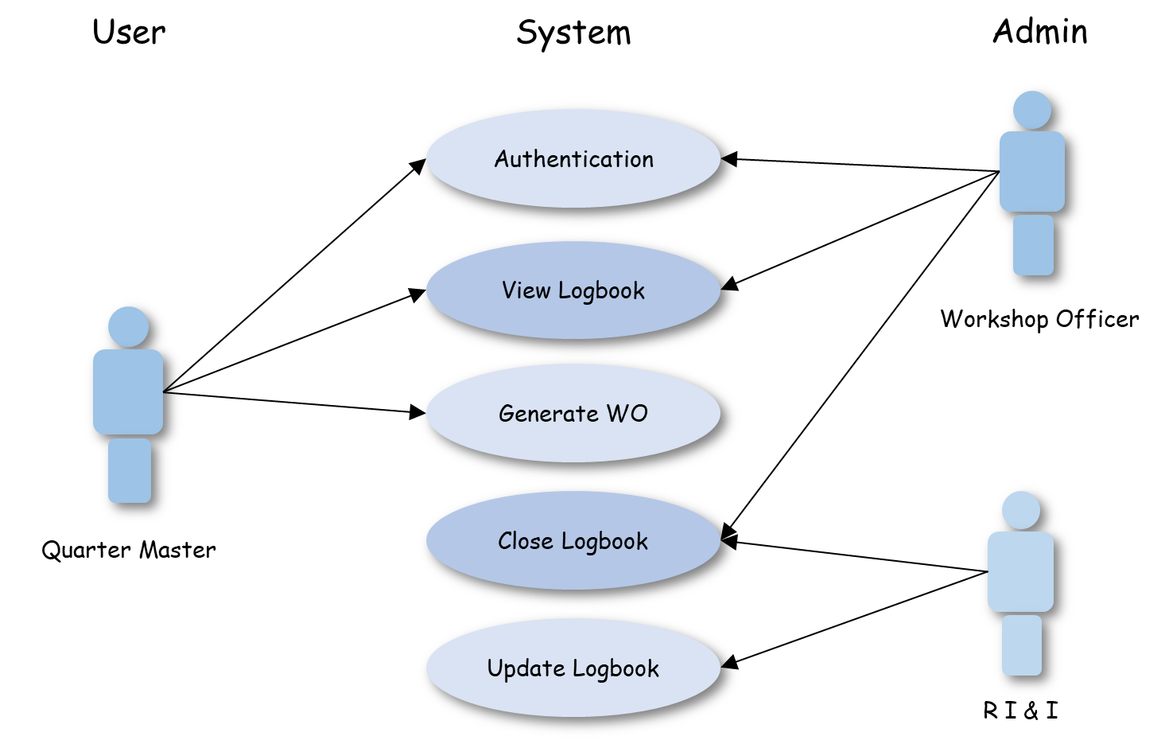

8

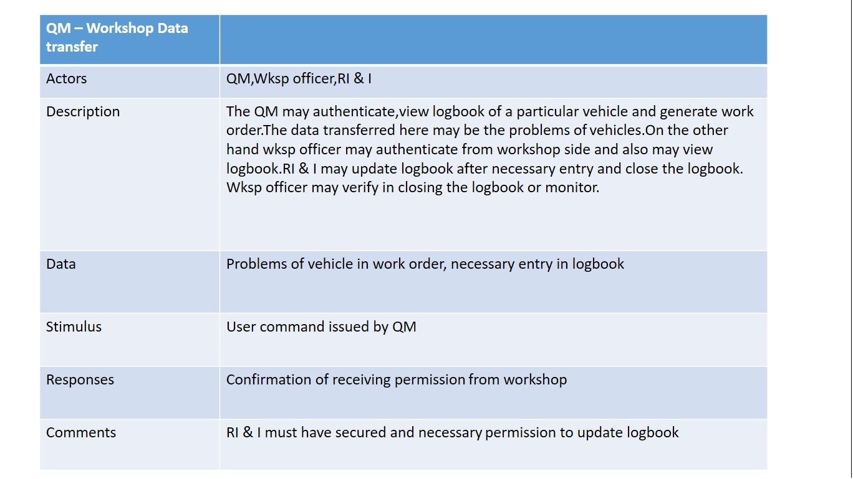

**Scenario From Workshop end:**

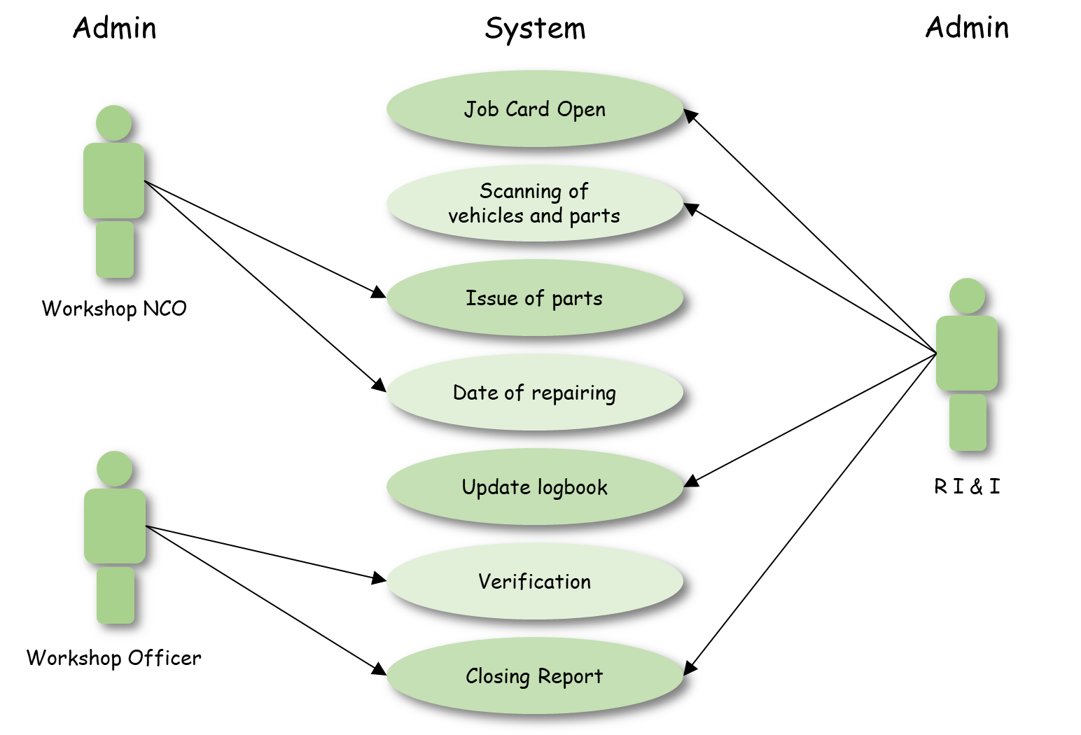

9

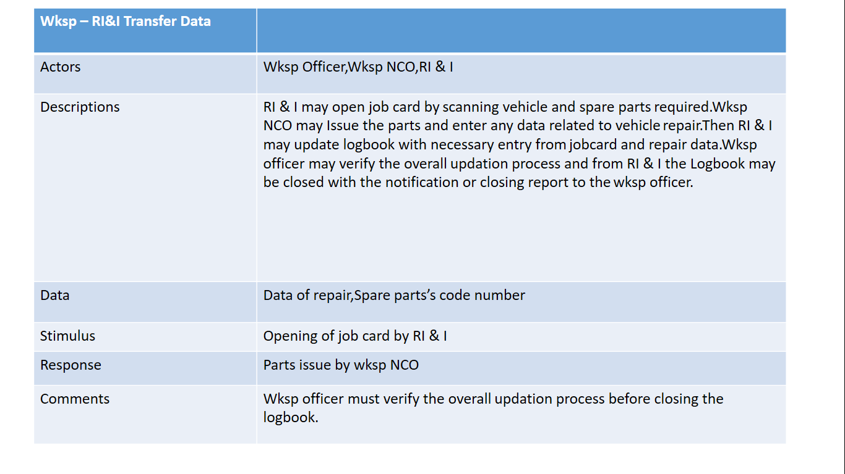

**8.3. Activity Diagram:**

**Scenario from Unit end:** 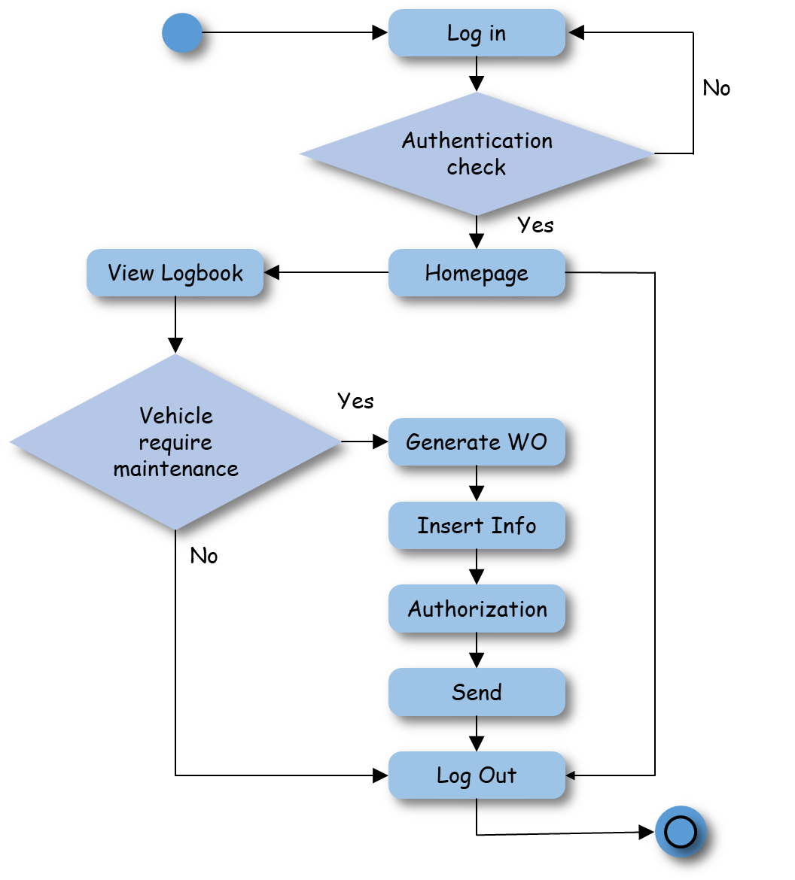

10

**Scenario from Workshop end:** 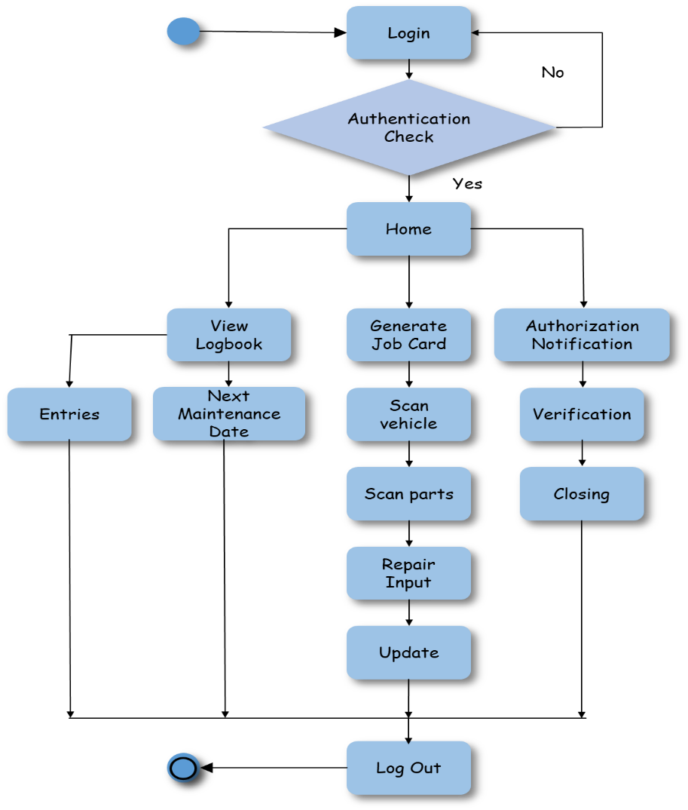

**8.4. Sequence Diagram:**

**Scenario From Unit end:**

11

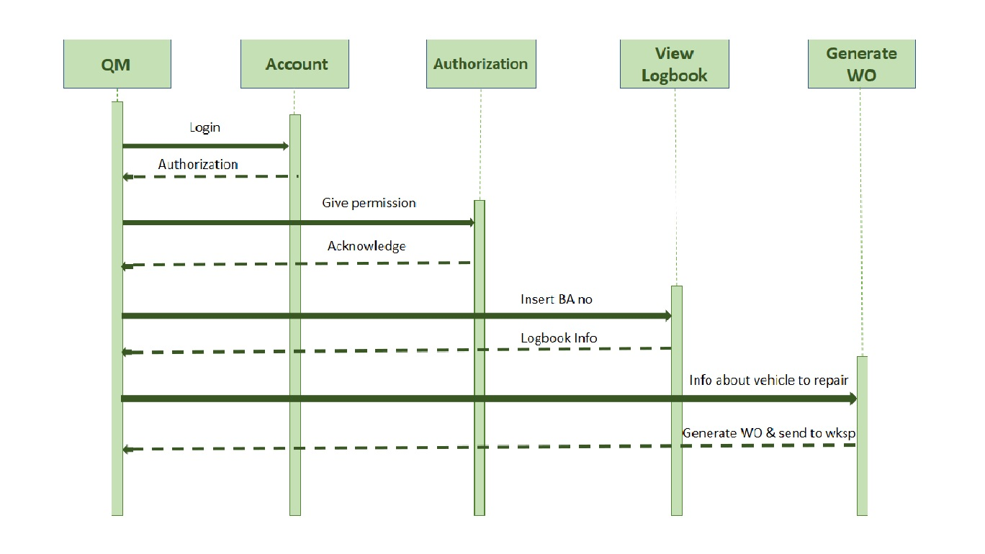

**Scenario From Workshop end:**

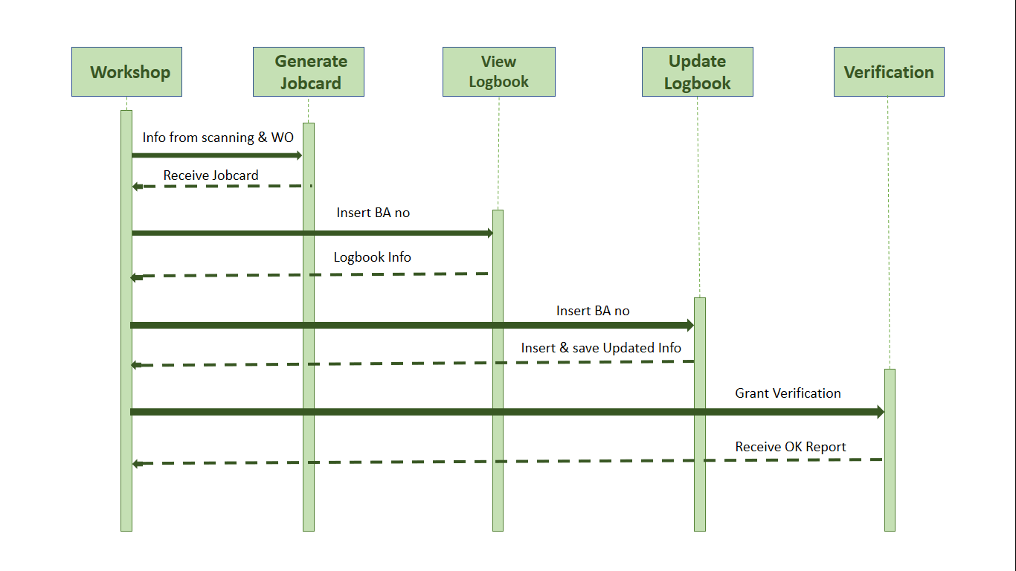

**9. System Evolution:**

12

**10. Appendices:**

* 1. **Annex A.** Survey Results Analysis.



13

**10.1. Annex B.** Survey Results Analysis



14

**10.1. Annex C.** Manual job card and logbook

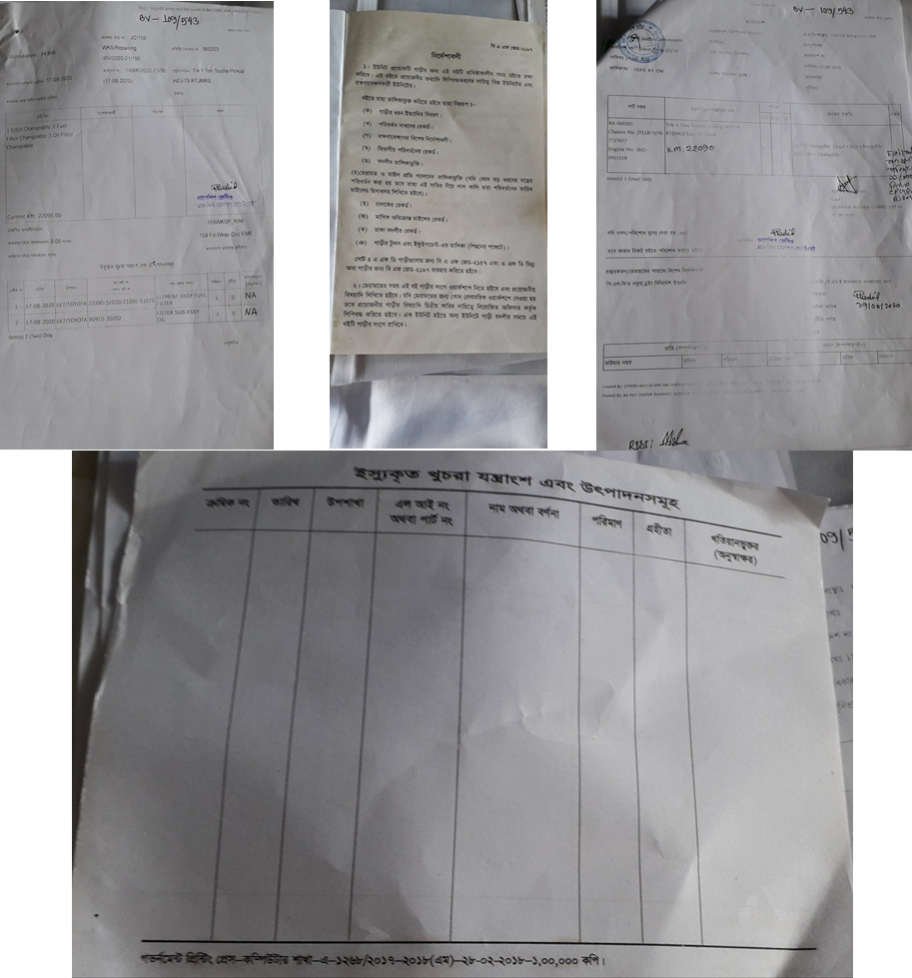

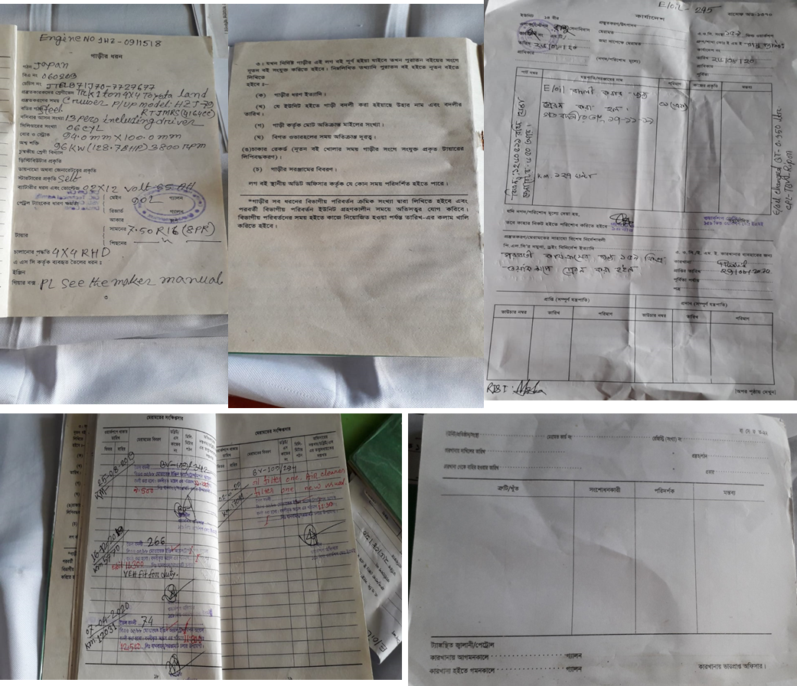

15

**10.4. ANNX D.**

**Interview with Workshop Officer**

**BA-10383**

**Capt Kazi Jerin Tasnim**

**137 FWC**

1.Q: Assalamu Alaikum sir. I am Lt Lopa from MIST, CSE dept. We are doing a project on vehicle logbook digitalization. Sir if you don’t mind to help us with some information and your opinion. Sir currently logbooks are maintained in handwritten process. Do you think creating a database will enhance the management procedure?

Answer: Yes, Lopa. I am glad to know about your project. Yes, definitely digitalizing logbooks will be really great but you need to take care of security of that process and also how to sign by the officer or if the logbook is maintained correctly or not. You have to think for any anomaly of the data in the logbook.

2.Q: Sir, what do you want about the whole process from entering a vehicle in the workshop with work order and then job card opening, will it be better if all those can be made digitalized?

Answer: Surely it will reduce great workload if work orders and job cards can be made totally computerized. I will be wanting if the entering process can also be somehow controlled and exit of the vehicles then we will be needing one less check post. But then also you need to keep in mind to check whether they are opening right job card or not and issuing the right parts or not as we are not signing manually.

3.Q: Sir normally how the logbooks are kept in the workshops of the repairing vehicles?

Answer: Well those are kept in RI & I in a shelf with numbered as different units but if it can be preserved by computer it will be easy to find out and enter new data.

Sir thank you for your valuable time. Your answers helped us a lot to determine the course of our project. Assalamu Alaikum sir.

16